1. A diagram of a diagram

   Description automatically generated with medium confidence  
   To understand compatibility, take the reference point consumer.   
   
   1. On the consumer side, we are reading the previous structured data as per new schema and no issue.



* 1. On the consumer side, we are reading the new structured data as per old schema (existing one) and no issue.

1. **Let’s walk through the code to see a backward compatibility scenario**: Consumer will upgrade its schema and still it will be working fine with old structured data.  
   A screenshot of a computer

   Description automatically generated
2. A screenshot of a computer

   Description automatically generated  
     
   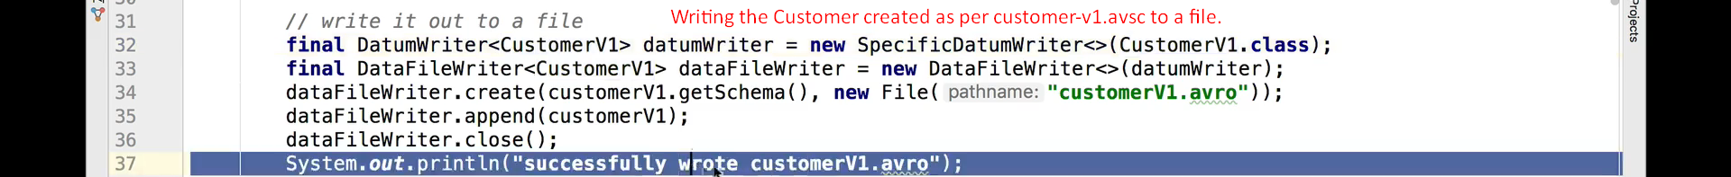  
     
   A close up of a computer code

   Description automatically generated  
     
     
   **Output**:   
   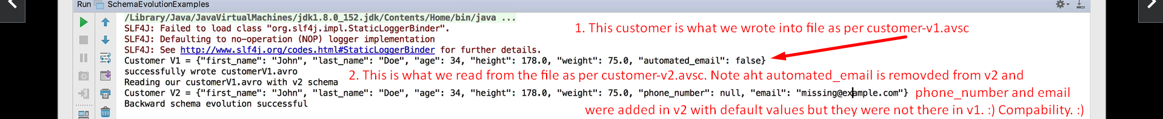
3. **Let’s walk through the code to see a forward compatibility scenario**: Consumer will use same schema on msgs based on new schema and still it will be working fine.  
   A screenshot of a computer

   Description automatically generated  
     
   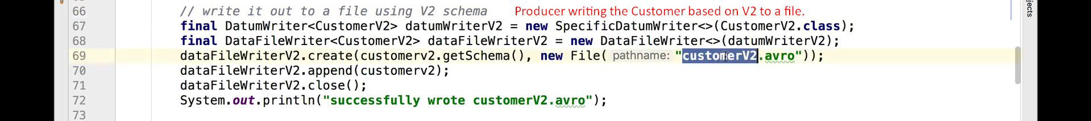  
     
   A close up of text

   Description automatically generated  
     
   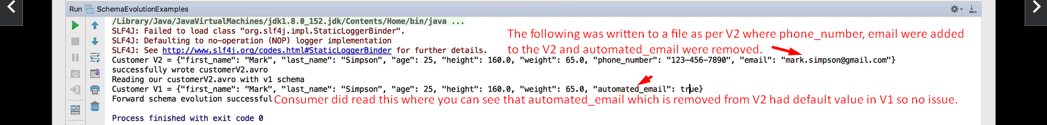  
   So, we can say that this is forward compatibility as Customer is using the previous V1 schema to read msg even though the msg structured got changed as per V2 from the producer side.